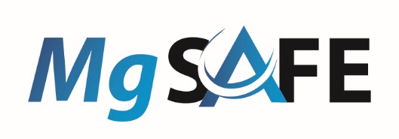

BioImplant meets MgSafe: Preliminary Agenda for the first joint virtual ETN Workshop on Thursday, 03.09.2020

9:00 – 9:20 | Introduction to the networks | Ted and Regine
9:20 – 11:05 | Short combined presentations of the ESRs: | 10 min talk + 5 min discussion /WP
 | BioImplant:
9:20 – 9:35 | (i) Polymers
9:35 – 9:50 | (ii) Magnesium & Coatings
9:50 – 10:05 | (iii) Magnesium-based Composite Materials
 | MgSafe:
10:05 – 10:20 | (i) Imaging Hard Tissue Remodelling
10:20 – 10:35 | (ii) Imaging Soft Tissue Remodelling and Inflammation
10:35 – 10:50 | (iii) Imaging Bone-implant Interface
10:50 – 11:05 | (iv) Mg Implants en route to the Clinics
11:05 – 12:00 | Computational approaches for coatings and sintering
11:05 – 11:30 | Christian Feiler (HZG): “Exploring Chemical Space using Computational Techniques”
11:30 – 11:55 | Vladimir Ivannikov (HZG): Simulation of Mg Sintering
12:00 – 13:00 | Lunch
13:00 - 13:50 | Medical implant design
13:00 – 13:25 | Alex Kopp (Meotec): Magnesium processing for Medical Implants
13:25 – 13:50 | Killian Reuss (Medical Magnesium): Certification of Magnesium Medical Implants
13:50 – 14:30 | Neural network techniques / modelling and simulation of degradation
13:50 – 14:10 | Jalil Nourisa (HZG): Simulation of osteosynthesis
14:10 – 14:30 | Reyhan Shirazi (NUIG): Physical Modelling of Magnesium Corrosion
14:30 – 15:00 | Cooperation, visits and secondments

